|  |  |
| --- | --- |
| **Project Case** |  |
| COMP6144  Web Programming |
| **Computer Science** | **O202-COMP6144-DU02-00** |
| ***Valid on*** *Odd Semester Year 2020/2021* | **Revision 00** |

1. Seluruh kelompok tidak diperkenankan untuk:

*The whole group is not allowed to:*

* + - Melihat sebagian atau seluruh proyek kelompok lain,

*Seeing a part or the whole project from other groups*

* + - Menyadur sebagian maupun seluruh proyek dari buku,

*Adapted a part or the whole project from the book*

* + - Mendownload sebagian maupun seluruh proyek dari internet,

*Downloading a part or the whole project from the internet,*

* + - Mengerjakan soal yang tidak sesuai dengan tema yang ada di soal proyek,

*Working with another theme which is not in accordance with the existing theme in the matter of the project,*

* + - Melakukan tindakan kecurangan lainnya,

*Committing other dishonest actions,*

* + - Secara sengaja maupun tidak sengaja melakukan segala tindakan kelalaian yang menyebabkan hasil karyanya berhasil dicontek oleh orang lain / kelompok lain.

*Accidentally or intentionally conduct any failure action that cause the results of the project was copied by someone else / other groups.*

1. Jika kelompok terbukti melakukan tindakan seperti yang dijelaskan butir 1 di atas, maka **nilai kelompok** yang melakukan kecurangan (menyontek maupun dicontek) akan di – **NOL** – kan.

*If the group is proved to the actions described in point 1 above, the score of the group which committed dishonest acts (cheating or being cheated) will be “Zero”*

1. Perhatikan jadwal pengumpulan proyek, segala jenis pengumpulan proyek di luar jadwal tidak dilayani.

*Pay attention to the submission schedule for the project, all kinds of submission outside the project schedule will not be accepted*

1. Jangan lupa untuk melihat kriteria penilaian proyek yang ditempel di papan pengumuman, atau tanya asisten anda.

*Don’t forget to look at the project assessment criteria that posted on the announcement board, or ask your teaching assistant.*

1. Persentase penilaiaan untuk matakuliah ini adalah sebagai berikut:

*Marking percentage for this subject is described as follows:*

|  |  |  |
| --- | --- | --- |
| **Tugas Mandiri**  *Assignment* | **Proyek**  *Project* | **UAP**  *Final Exam* |
| - | 100% | - |

1. Software yang digunakan pada matakuliah ini adalah sebagai berikut:

*Software will be used in this subject are described as follows:*

|  |
| --- |
| **Software**  *Software* |
| PHP Composer 1.10.7  PHP Storm 2020.1.2  Visual Studio Code  Laravel Framework 7  XAMPP 7.4.7  Firefox / Chrome |

## Ekstensi file yang harus disertakan dalam pengumpulan tugas mandiri dan proyek untuk matakuliah ini adalah sebagai berikut:

*File extensions should be included in assignment and project collection for this subject are described as follows:*

|  |  |
| --- | --- |
| **Tugas Mandiri**  *Assignment* | **Proyek**  *Project* |
| - | Folder Project (PHP, SQL, Image Files (JPG / PNG), ENV, HTML, CSS, SCSS, JS, JSON, HTACCESS, ARTISAN) |

General Provisions:

* Use **MySQL** asdatabase and must using **Laravel Migration** features.
* **All file upload** feature such as image and document must be **stored to server storage**.
* Use PHP Framework **Laravel 7** to build the project.
* Use Laravel **MVC** concept (**Model, View, Controller**) to build the project.
* Use **Eloquent Query / Query Builder** to work with database.
* You are free to design your own database table **based on given requirements**.
* Print screen given below is only an example. You are free to create your own user interfaces.
* It is **prohibited** to install any kind of Laravel packages. You must use fresh installation of **Laravel 7**.
* Only **validation** in the **backend** (using Laravel) will be graded.

## Soal

*Case*

**Just Du It !**

**Just Du It !** is a famous Indonesian technology company specializing in branded shoe, to expand its business, **Just Du It !** wants to create a website for their shop. In that website, people can find information about the **Just Du It !**’s products and order it. This website enables the customers to know what inside **Just Du It !** is.

As a web developer, you are asked to create a website using **Laravel** **7** for this online shop. There are three types of user’s role in this website: **Admin**, **Member**, and **Guest** (**non-logged-in user**)

* + - 1. **Login**

This page allows user to log in to the website. Display an **error message** on the login page if user enters wrong combination of **Email** and **Password**.

If user has entered correct **Username** and **Password**, the page will be redirected to the **Home Page** **for customer** and **if user checks the “Remember Me**” checkbox, the website will save the **Username** and **Password** using cookies for **2 hours**.

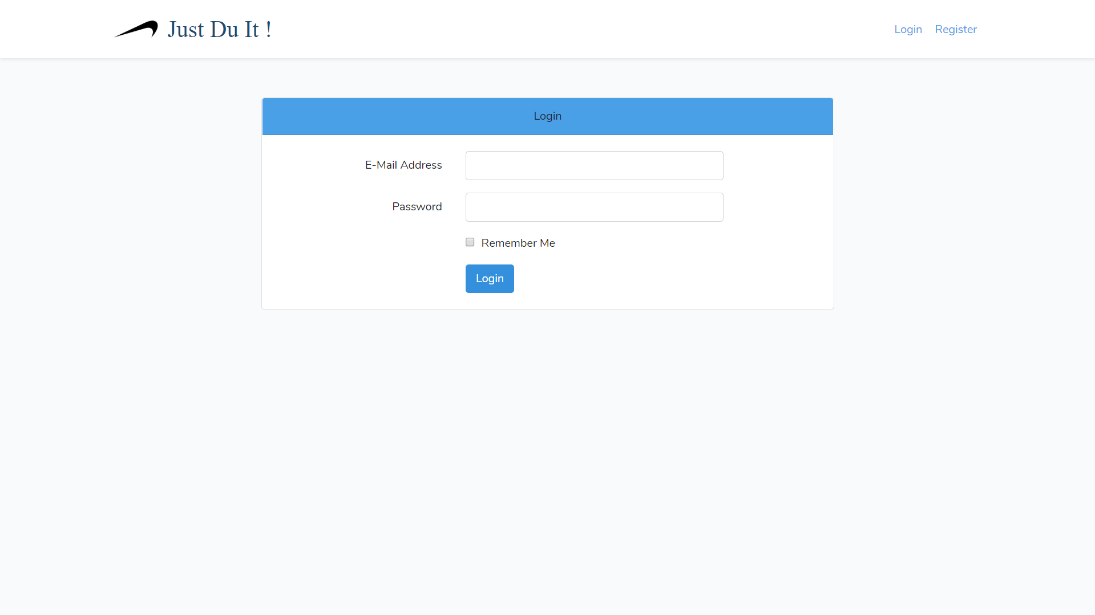

***Figure 1. Login Page***

1. **Register**

This page allows guests to **register** themselves as **Just Du It !’s** member. Display an **error message** if user input incorrect personal data. The following table shows the existing fields on this page and the validation for each field:

|  |  |
| --- | --- |
| **Field** | **Information** |
| **Username** | Must be **filled** |
| **Email Address** | Must be **filled** with **email validation** and **unique** |
| **Password** | Must be **filled** and **minimum 3 characters length** |
| **Confirm Password** | Must be **filled** and **same with password** |

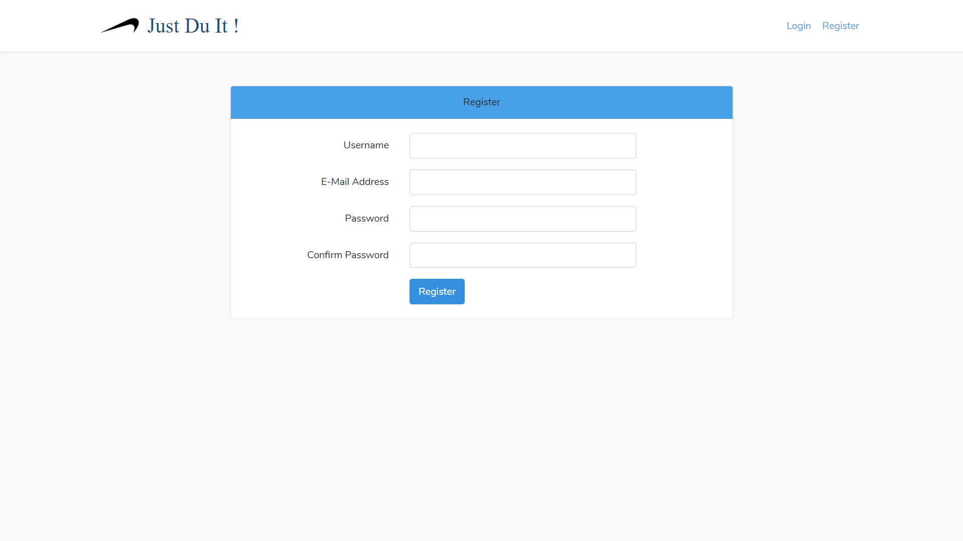

***Figure 2. Register Page***

1. **Home Page**

This page allows user to see all **Just Du It !’s products**. This page is accessible for **all user.** In this page User can also **search by name of shoe and shoes paginate by 6.** In this page, guest can **Login** or **Register.**

Logged in member will have extra button on the side bar, which is **view all shoe, cart** and **history**.

**As if for member, each shoe can be clicked to redirect into “Shoe’s Detail Page”.**

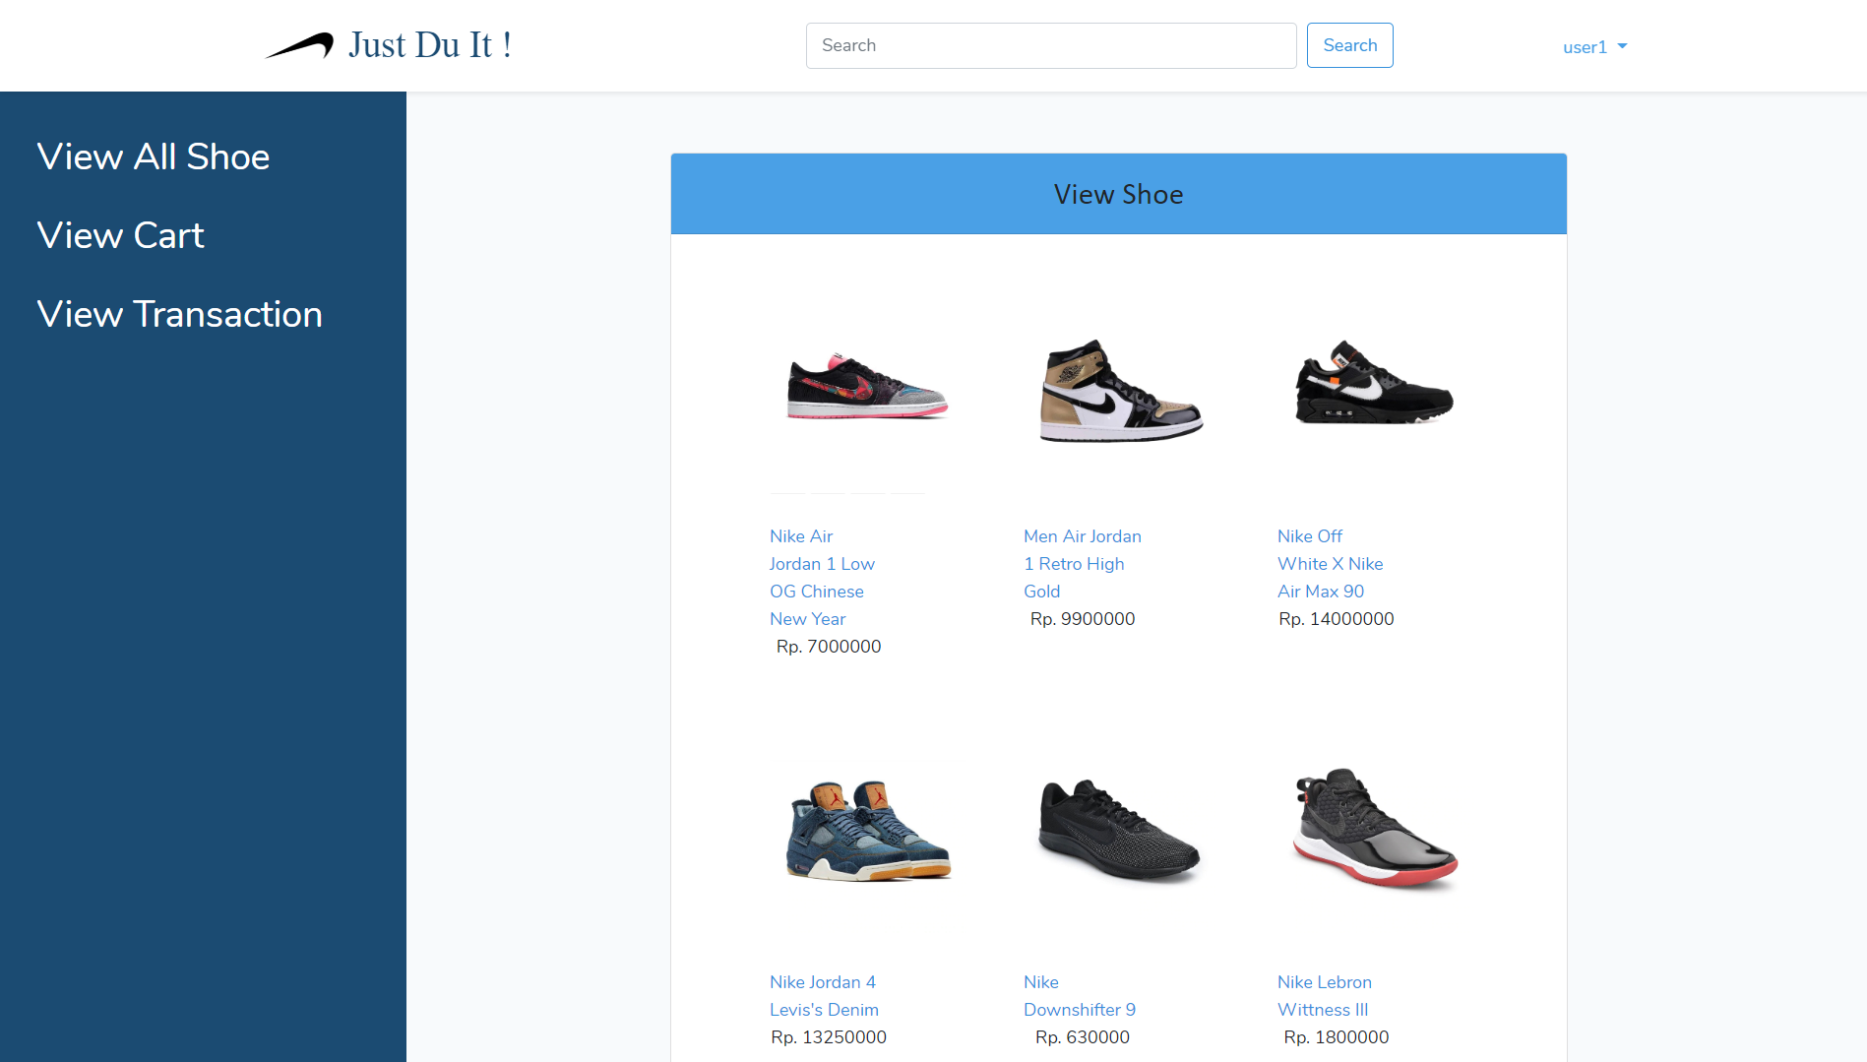

***Figure 3. Home Page (for Member)***

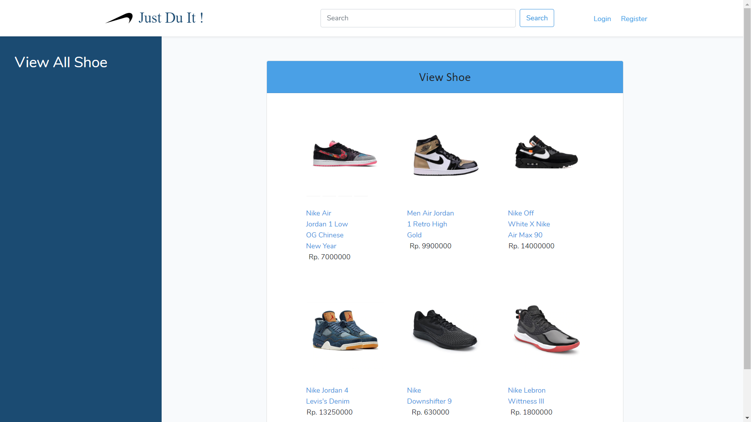

***Figure 4. Home Page (for Guest)***

1. **View Shoe Detail**

This page is accessible for **all user**. This page shows product’s detail based on product clicked. This page is also **included with a search field**, so you can search **products** **by Shoe’s Name**. **This page displays Shoe’s image, name, price and description.**

In this page, there is **add to cart text** that can be clicked and redirect to “**add to cart page**”for member, **update shoe text** that can be clicked and redirect to “**update shoe”** for admin.

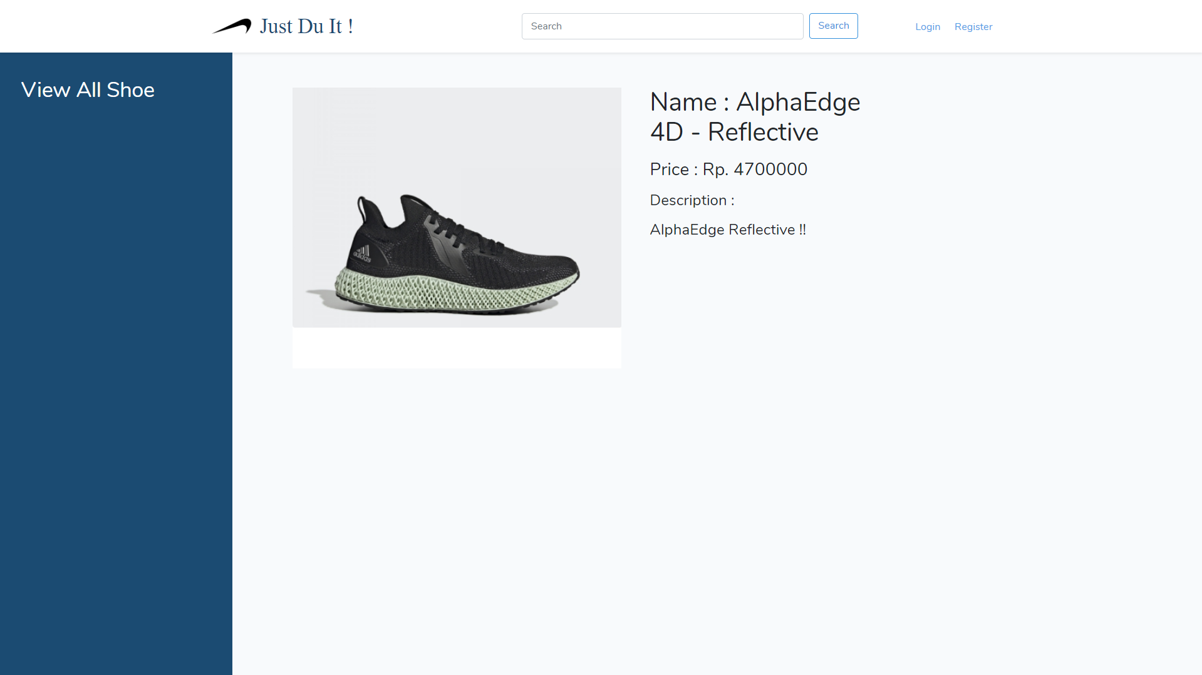

***Figure 5. Shoe’s Detail Page (for Guest)***

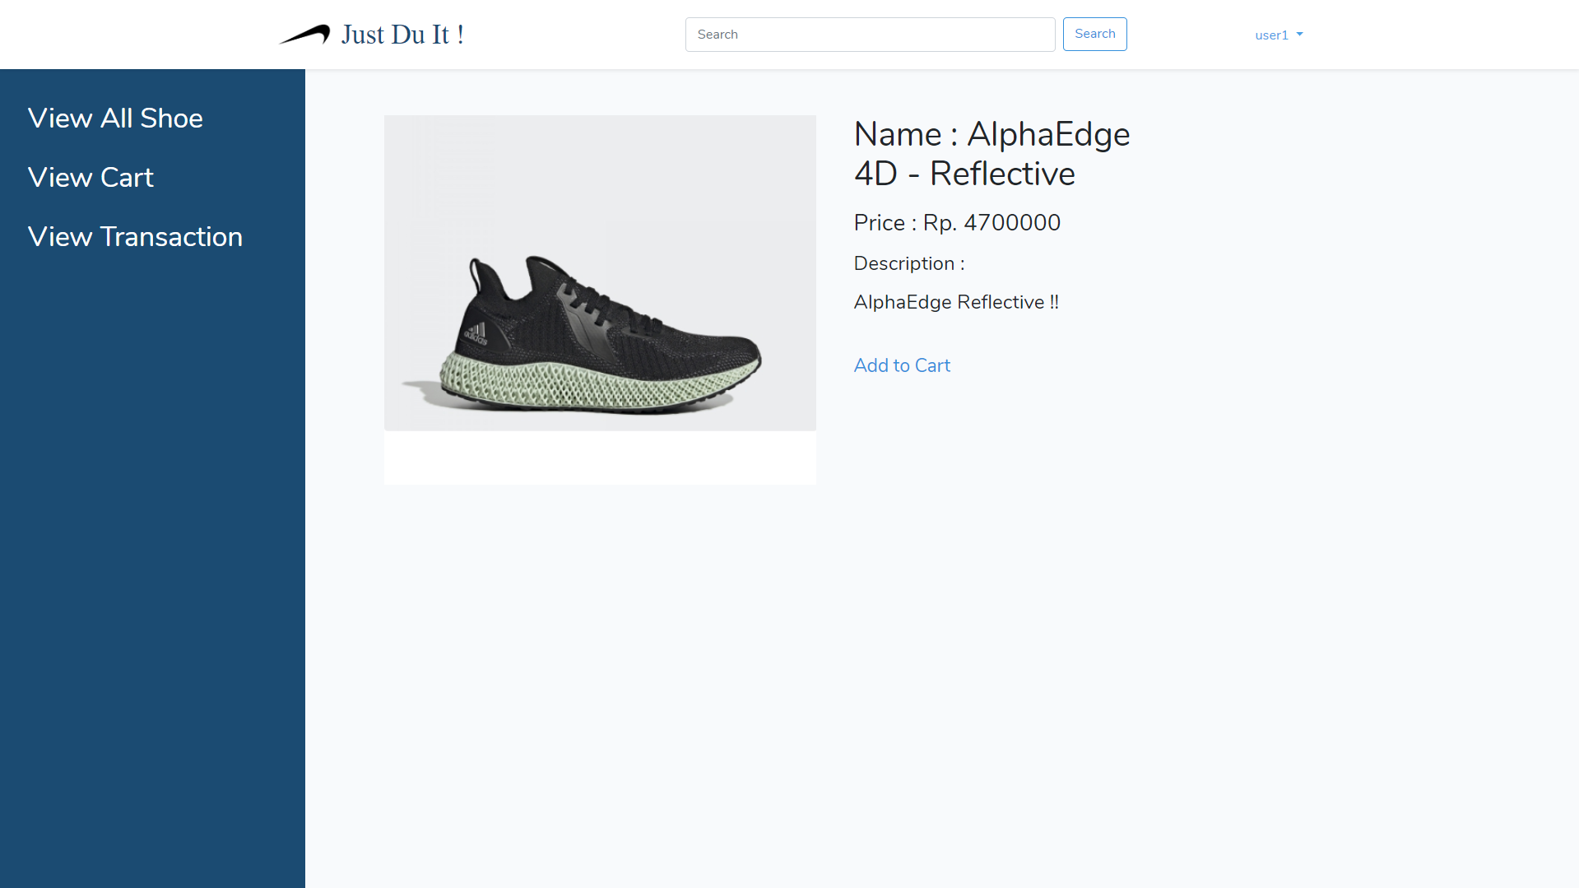

***Figure 6. Shoe’s Detail Page (for Member)***

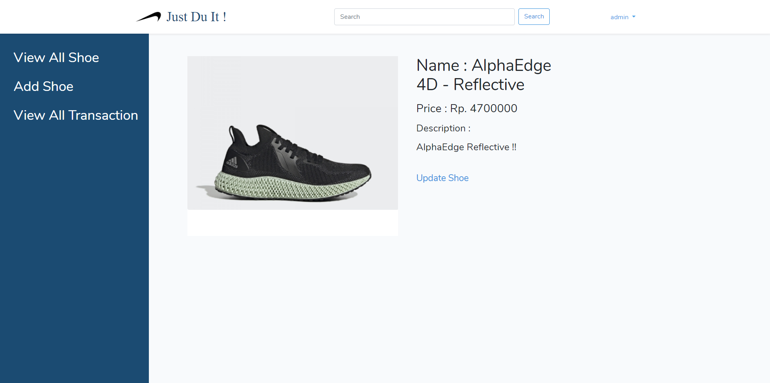

***Figure 7. Shoe’s Detail Page (for Admin)***

1. **Add to Cart Page**

This page is only accessible for **member**. In this page, member can input **quantity** of product that member want to add into their cart and click add to cart button. After that, the product will be added to the cart and member will **be redirected to view all shoe page**.

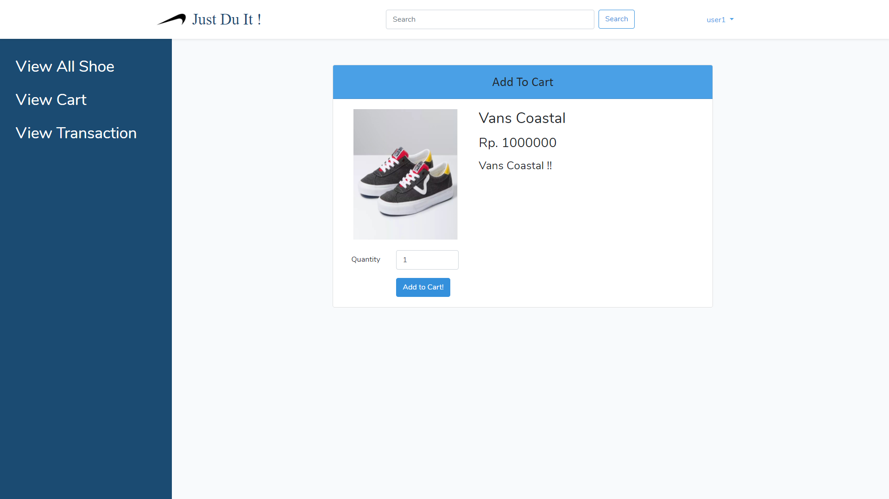

***Figure 8. Add to Cart Page***

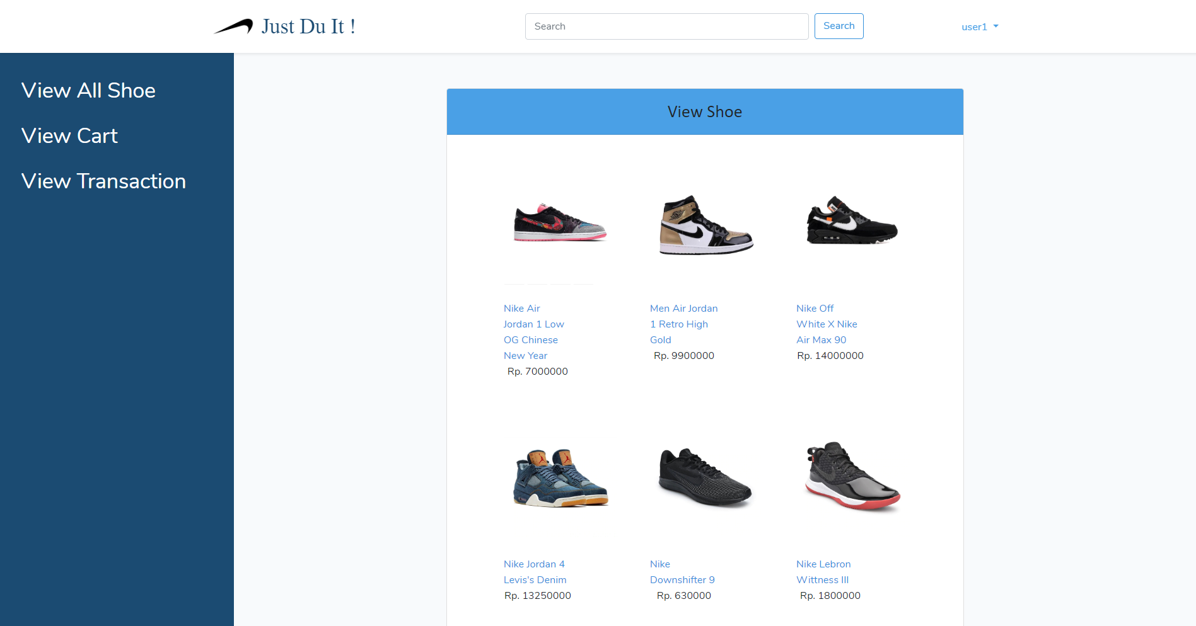

***Figure 9. After Add to Cart***

1. **Cart List Page**

This page is only accessible for **member**. This page displays all product that added to cart, and view their **image**, **name**, **total price**, **quantity with edit button** and if clicked, member will redirect to **update cart**. In this page, member can **Check out** the cart, **validate** that Checkout button shown only when **cart not empty**. If member clicked **checkout** button, it would **clear** the cart, and **add** a new **transaction** in the **“Transaction History Page”.**

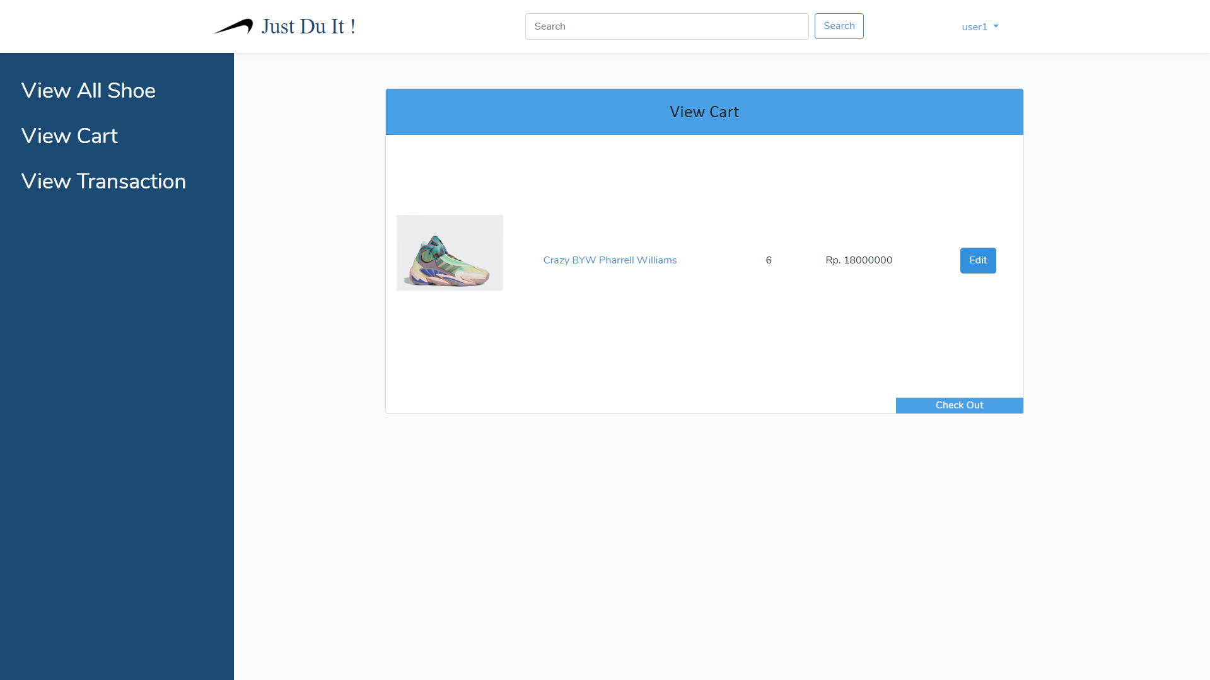

***Figure 10. Cart List Page***

1. **Edit Cart**

This page is only accessible for member. This page displays a product information from the cart such as: **image**, **name**, **total price**, and **quantity.** Memberscanchange the item quantity by changing the quantity value and update the cart by clicking the **Update Cart button.** Member can **delete the item from the cart** by clicking the **delete** **button**.

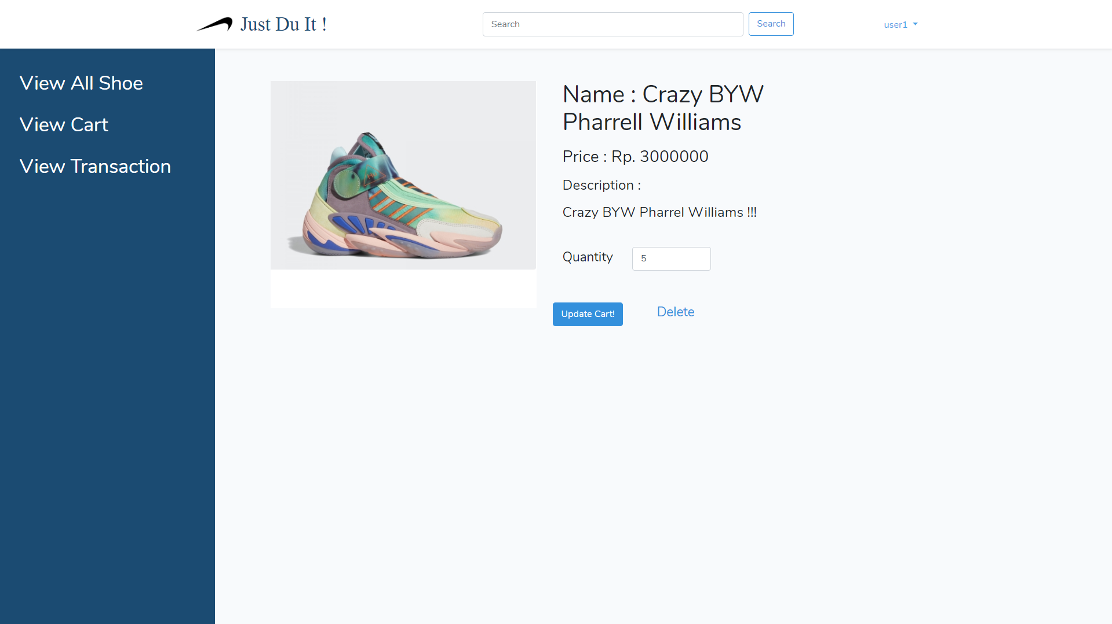

***Figure 10. Edit Cart Page***

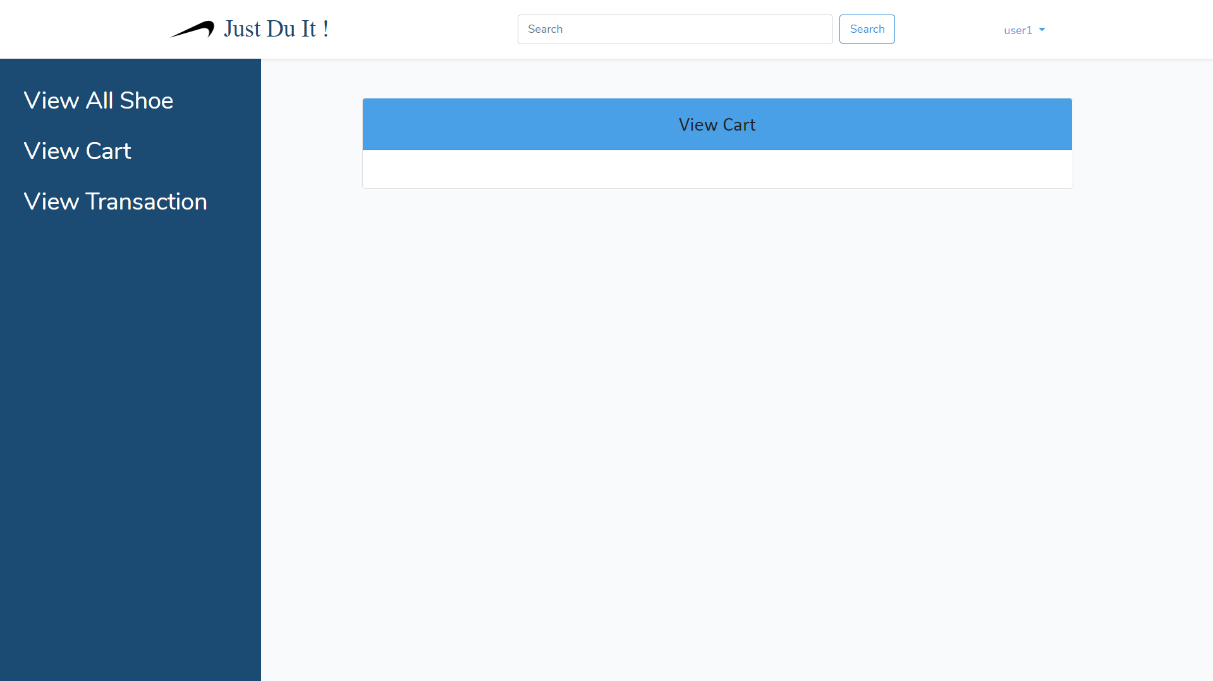

***Figure 11. After Edit Cart ( delete cart )***

1. **View Transaction Page**

History page can be accessed by clicking **View Transaction** button below cart, and only accessible for **member**. History page **will display all transaction date with the image of shoes bought by the member**.

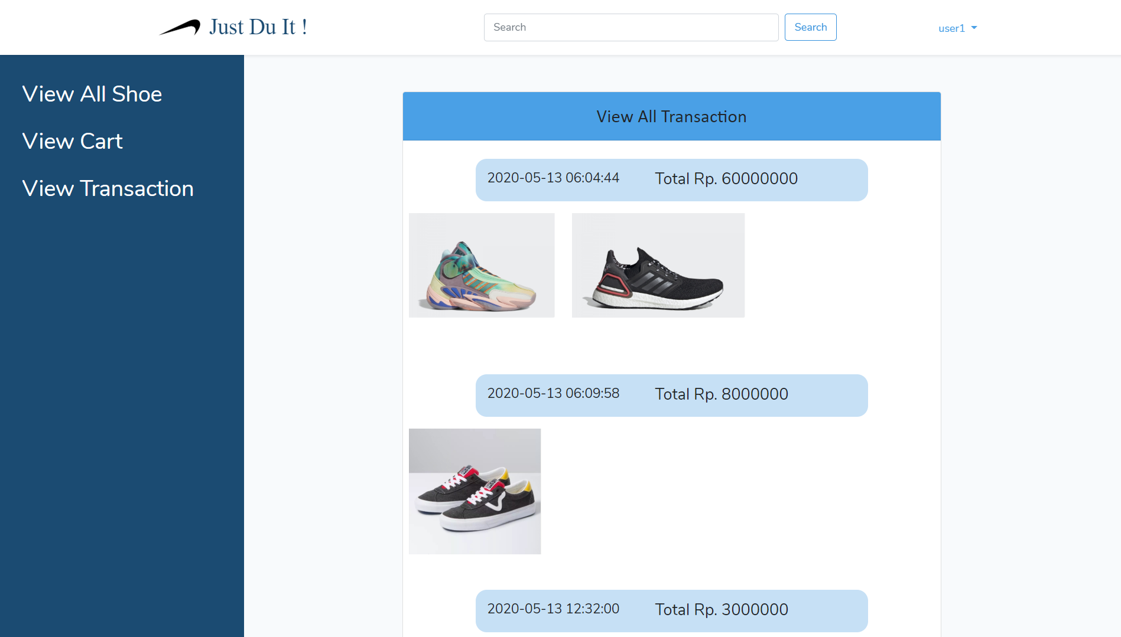

***Figure 12. View Transaction Page***

1. **Admin Panel**

This page accessible by **Manager**. In this page admin can **add product**, **show all shoe**, and **show all transaction.**

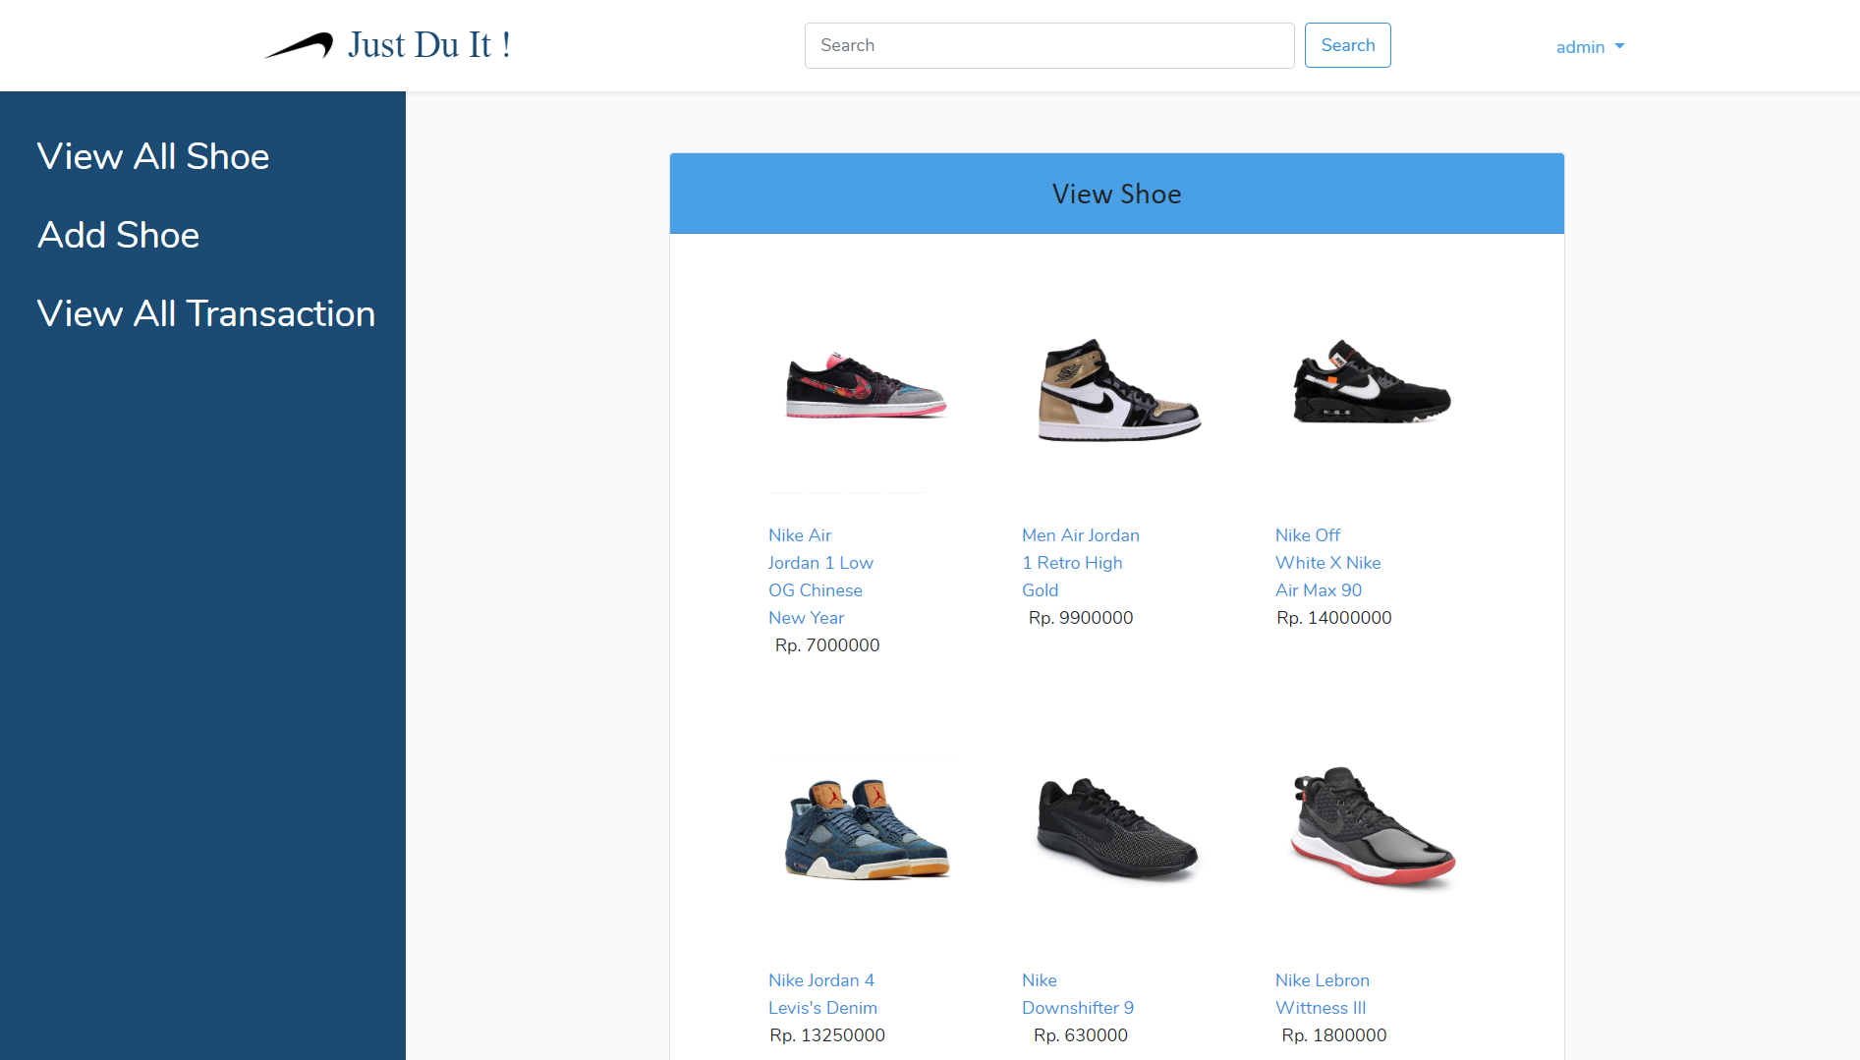

***Figure 13. Admin Page***

1. **Add Shoe**

This page is only accessible for Admin. In this page, manager can **add** new shoe. This page can be access when **Admin** choose “Add Shoe” Button.

The following table shows existing fields in the page and the validation for each field:

|  |  |
| --- | --- |
| **Field** | **Information** |
| **Name** | Must be **filled** |
| **Description** | Must be **filled** |
| **Price** | Must be **filled** and **minimal** **100** |
| **Image** | Must be **filled,** must be **image** |

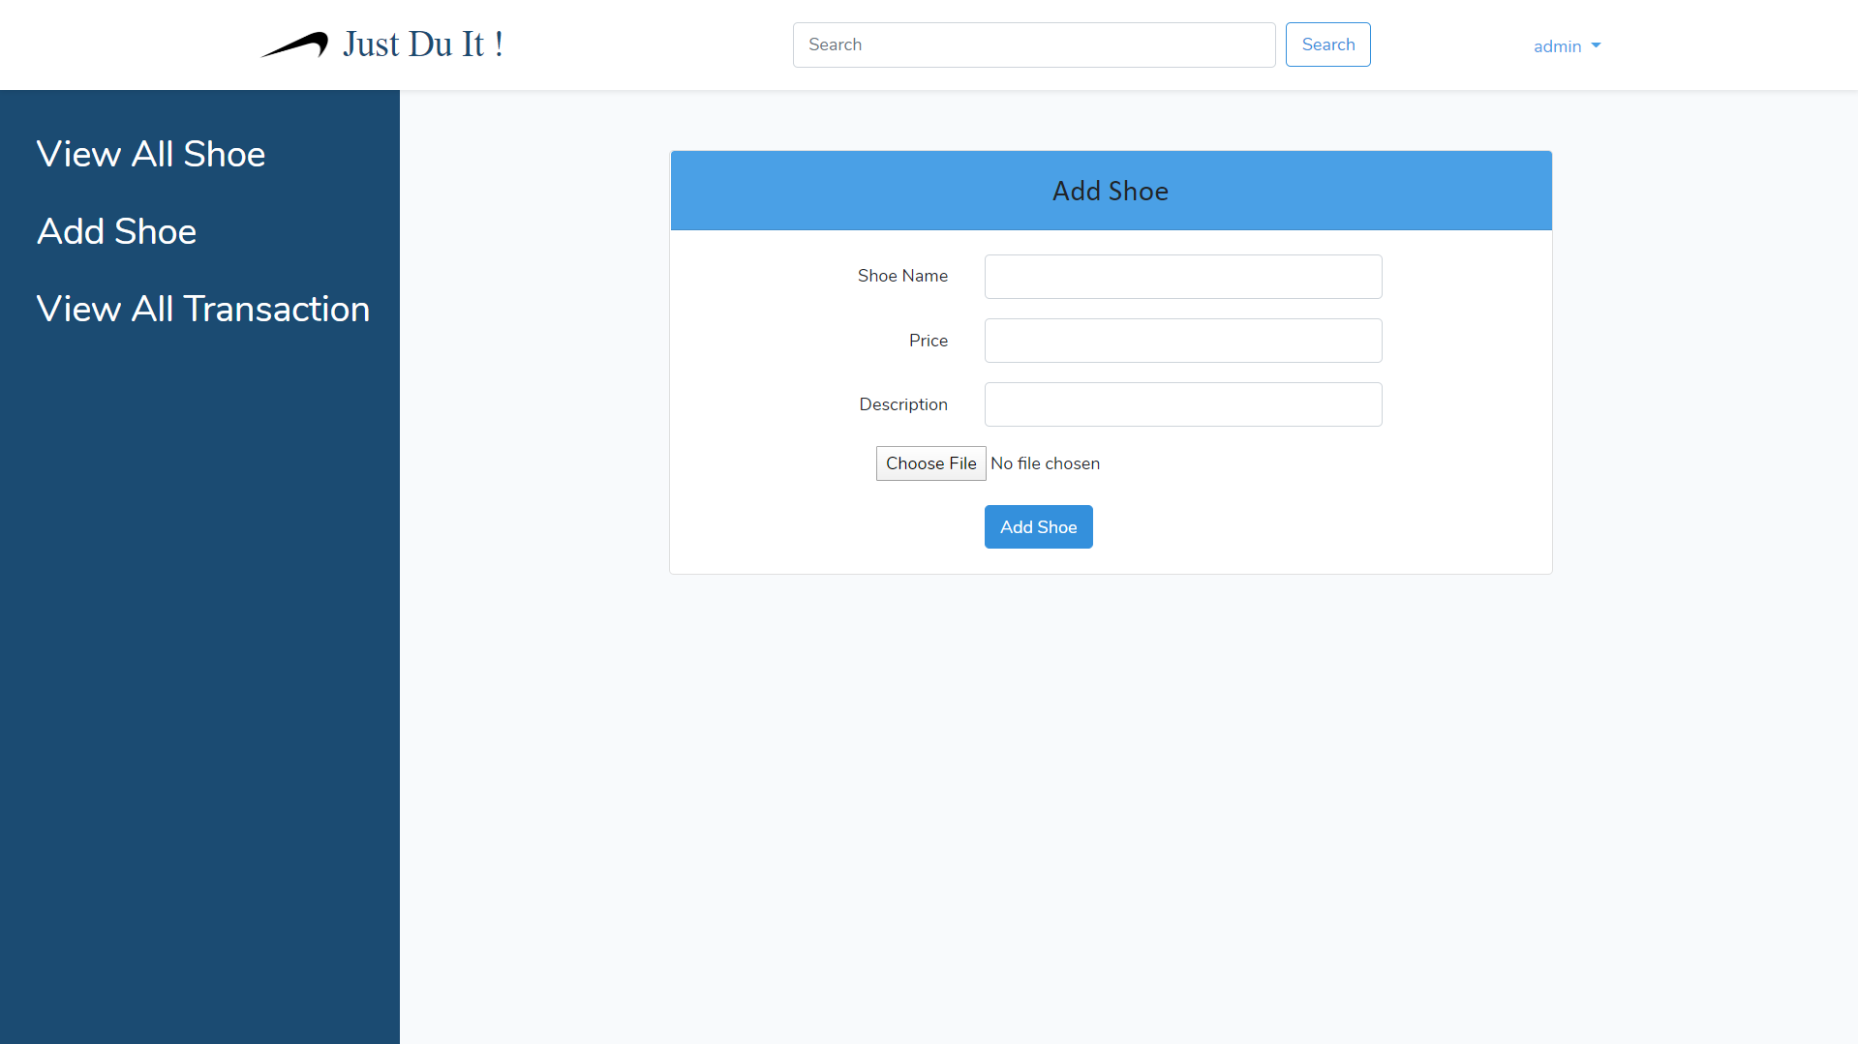

***Figure 12. Add Shoe Page***

1. **Update Shoe**

This page is only accessible for Admin. In this page, manager can **update** a shoe. This page can be accessed when **Admin** choose “Update Shoe” Button in shoe detail page. If admin decide to not choose a new image, the shoe image will remain **the same as the old one.**

The following table shows existing fields in the page and the validation for each field:

|  |  |
| --- | --- |
| **Field** | **Information** |
| **Name** | Must be **filled** |
| **Description** | Must be **filled** |
| **Price** | Must be **filled** |
| **Image** | **Nullable** |

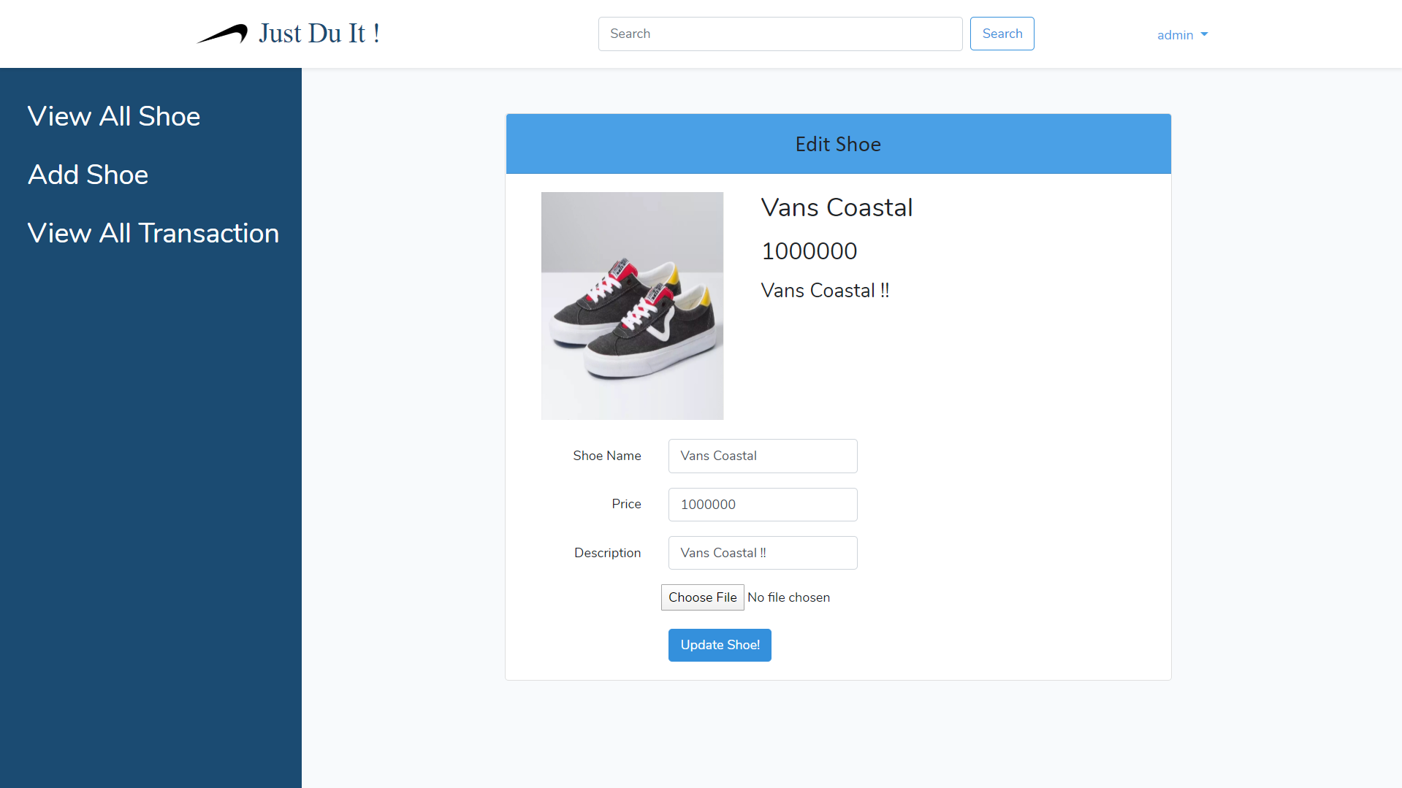***Figure 13. Update Shoe Page***

1. **View All Transaction Page**

This page can be accessed by clicking **View All Transaction** and only accessible for Admin. History page **display all transaction date with the image of shoe bought by all member**.

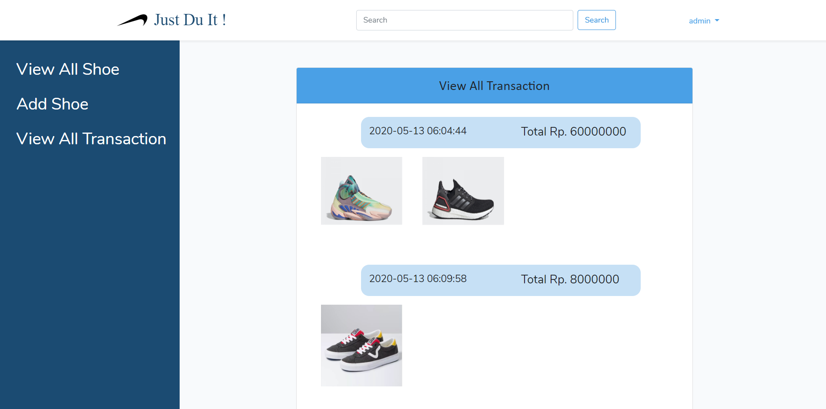

***Figure 12. All Transaction Page***

Here are the rules that you must follow to create your project:

1. Use appropriate software for this subject based on **Sistem Praktikum** that can be downloaded from Binusmaya.
2. Collect appropriate files for this subject based on **Sistem Praktikum** that can be downloaded from Binusmaya.
3. Include the other files that can support your project, such as:
   * All files in your project
   * Other files (image, audio, video, etc.) used in your project
   * *.DOC file (documentation of your project) that contains all pages in your project, reference links of additional files (image, audio, video, etc.) used in your project, the description about how to use your application, etc
4. If there are some hidden creativities, please note them in the existing documentation because they can greatly affect your project score

**References Link:**

<https://www.adidas.co.id/alphaedge-4d-shoes-goodbye-gravity-1.html>

<https://www.adidas.co.id/alphaedge-4d-reflective-shoes.html>

<https://www.adidas.co.id/catalog/product/view/id/216561/>

<https://www.adidas.co.id/catalog/product/view/id/193490/>

<https://www.adidas.co.id/ultraboost-20-shoes-21.html>

<https://www.vans.com/shop/vans-coastal-vans-sport-black-true-white>

<http://pngimg.com/imgs/logos/nike/>

<https://www.blibli.com/p/nike-lebron-witness-iii-sepatu-basket-pria-bq9819-001/pc--MTA-3222163?ds=MAD-60074-00109-00001&source=SEARCH&sid=09620907559d74dc&cnc=false&pickupPointCode=PP-3088689>

<https://www.blibli.com/p/nike-downshifter-9-sepatu-running-pria-aq7481-005/ps--TOI-49844-00868?ds=TOI-49844-00868-00005&source=SEARCH&sid=09620907559d74dc&cnc=false&pickupPointCode=PP-3016520>

<https://www.blibli.com/p/nike-off-white-x-nike-air-max-90-sepatu-sneaker-pria-black/ps--BAM-60054-00181?ds=BAM-60054-00181-00020&source=SEARCH&sid=09620907559d74dc&cnc=false&pickupPointCode=PP-3051680>

<https://www.blibli.com/p/nike-jordan-4-levi-s-denim-blue-sepatu-sneakers-8-denim-blue/pc--MTA-4558718?ds=HOS-60058-00147-00004&source=SEARCH&sid=09620907559d74dc&cnc=false&pickupPointCode=PP-3072646>

<https://www.blibli.com/p/nike-men-air-jordan-1-retro-high-gold-top-3-sepatu-sneakers-pria-black-gold-861428-001/ps--TRO-60021-00186?ds=TRO-60021-00186-00002&source=SEARCH&sid=09620907559d74dc&cnc=false&pickupPointCode=PP-3033805>

<https://www.blibli.com/p/nike-air-jordan-1-low-og-chinese-new-year-sepatu-sneaker-pria/pc--MTA-6425965?ds=HOS-60058-00236-00011&source=SEARCH&sid=09620907559d74dc&cnc=false&pickupPointCode=PP-3072646>